**Source Code:**

create database college;

use college;

drop table if exists enrollment;

create table enrollment

(

ID int,

FullName varchar(100),

ContactNo bigint,

Residence varchar(100),

Semester int

);

alter table enrollment add Batch int;

insert into enrollment values (101, 'Deepak', '9812', 'Bhaktapur', 19, 1);

insert into enrollment values (202, 'Sushant', '9823', 'Baneshwor', 22, 4);

alter table enrollment drop column Semester;

truncate table enrollment;

delete from enrollment where FullName = 'Sushant';

update enrollment set FullName = 'Nirajan' where FullName = 'Deepak';

select * from enrollment;

**OUTPUT:**



**Data insert into enrollment table**



**Add column “Batch ”into student table**



**Added values into “Batch”**



**Dropped “Semester” from the table**



**Truncate record from table**

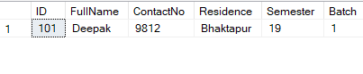

**Delete all record of student from name ‘Sushant’**

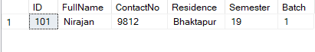

**Update to change the name of record name =’Deepak’ to ‘Nirajan’**